
OPERATING SYSTEMS HACKATHON PROJECT REPORT

LINUX COMMAND EXECUTION TIME PROFILER
A C-based command-line utility to measure the execution time and resource usage of Linux commands

Project Domain: Operating Systems, Linux, System Programming
Language: C | Environment: Ubuntu on WSL2 | Compiler: GCC
Submitted by
S. No. | Roll Number | Student Name
1 | 2520030432 | K ANUSRI
2 | 2520030440 | K SAI ANSHU
3 | 2520030193 | K DHEERAJ
4 | 2520030028 | B MOHITH

Faculty Guide
V MUNIRAJU

Date of submission: [17-10-26]

Abstract
Operating systems expose a set of system calls that let programs create processes, run other programs and measure how those programs behave. This project, the Linux Command Execution Time Profiler, uses those system calls to build a small command-line tool in C that runs a Linux command entered by the user and reports how long it took and what resources it used.
The profiler reads a space-separated command, creates a child process with fork(), replaces the child with the requested program using execvp(), and waits for it with wait4(). Elapsed wall-clock time is measured with clock_gettime(CLOCK_MONOTONIC), while user CPU time, system CPU time and maximum resident set size are obtained from the resource-usage structure filled in by wait4(). The exit status, or the terminating signal, is also reported. The program keeps accepting commands until the user types exit.
The tool was developed and tested on Ubuntu running under WSL2 and compiled with GCC. Observed terminal results for ls -l, sleep 2 and an invalid command abcxyz are documented in this report, together with the design, the system calls used, current limitations and possible future enhancements. The current version does not implement shell parsing, so pipelines, redirection and quoted arguments are not supported.
Table of Contents
Abstract 1
1. Introduction 3
2. Background and Problem Statement 3
2.1 Background 3
2.2 Problem Statement 3
3. Project Objectives 3
4. Scope and Intended Use 4
5. System Requirements 4
6. Technologies Used 4
7. System Architecture 5
8. Program Execution Workflow 5
9. Methodology and Implementation 6
9.1 Input Handling 6
9.2 Parsing the Command 7
9.3 Process Creation, Timing and Waiting 7
9.4 Computing and Reporting Results 7
9.5 Error Handling 8
10. Important Linux System Calls and APIs 8
10.1 fork() 8
10.2 execvp() 8
10.3 wait4() 8
10.4 struct rusage 8
10.5 clock_gettime() 8
10.6 Supporting functions 9
11. Compilation and Execution Procedure 9
12. Testing Methodology and Test Cases 9
12.1 Purpose of Each Test 10
13. Results and Discussion 11
13.1 Normal Command Execution: ls -l 11
13.2 Timing Validation: sleep 2 11
13.3 Error Handling: abcxyz 12
13.4 Summary of Observed Values 13
13.5 Discussion 13
14. Actual Terminal Screenshots 13
15. Limitations 14
16. Future Enhancements 14
17. Team Contributions 14
18. Conclusion 15
19. References 15
20. GitHub Repository Information 16
Appendix A: Complete Source Code (profiler.c) 17

1. Introduction
When a user types a command such as ls -l in a terminal, the shell asks the operating system to create a new process, load the program into it, run it, and report back when it ends. Most users never see these steps, yet they are central to how Linux works. The same steps also provide a convenient place to measure how long a command takes and how much CPU time and memory it uses.
The Linux Command Execution Time Profiler is a small C program that performs these steps explicitly. It acts as a minimal wrapper around any simple Linux command: it starts the command, waits for it to finish and prints an execution report. The project is intended to demonstrate process creation, program execution, process waiting and resource measurement on Linux, which are core Operating Systems topics.
Naming note. The hackathon title of the project is "Linux Command Execution Time Profiler". The program banner and the repository README use the shorter name "Linux Command Execution Profiler". Both names refer to the same program.

2. Background and Problem Statement

2.1 Background
On Linux, a new program is normally started in two steps. First, an existing process calls fork() to create a copy of itself, called the child. Then the child calls one of the exec functions to replace its own program image with the requested command. The original process, the parent, can wait for the child to terminate and learn its exit status. This fork–exec–wait pattern is how shells run commands.
The kernel also keeps accounting information for each process, such as the CPU time spent in user mode and in kernel mode and the largest amount of physical memory the process occupied. A parent that waits for a child with the right system call can receive this accounting information.

2.2 Problem Statement
As stated in the project README: create a tool that measures the execution time and resource usage of Linux commands. The tool should run a command supplied by the user, report how long it took, report CPU and memory usage, show how the command ended, and handle invalid or empty input without crashing.

3. Project Objectives
- Measure the elapsed execution time of a command.
- Measure user CPU time and system CPU time.
- Display the maximum memory usage of the command.
- Display the exit status of the command, or the signal that terminated it.
- Handle invalid and empty commands without terminating the profiler.
- Allow the user to execute multiple commands in one session.
- Demonstrate fork(), execvp(), wait4() and clock_gettime() in a working program.

4. Scope and Intended Use
The profiler is intended as an educational tool and a simple observation aid. It lets a student or user run a command and see, in one report, how long it took and what resources it consumed. It is suitable for simple commands with space-separated arguments, such as pwd, ls -l and sleep 2.
The following are outside the scope of the current version: shell parsing, pipelines, input/output redirection, shell operators, quoted arguments containing spaces, command history, saved reports, and comparison between runs. This report makes no claims about performance improvement, benchmarking, or comparison with other profiling tools.

5. System Requirements
Item | Requirement
Operating system | Linux. The project was developed and tested on Ubuntu running under WSL2 on Windows.
Compiler | GCC (GNU Compiler Collection).
Libraries / headers | Standard C library and POSIX/Linux headers: stdio.h, stdlib.h, string.h, time.h, unistd.h, sys/wait.h, sys/resource.h.
Tools | A Linux terminal. The Nano editor was used for editing the source file.
Optional | Git, for cloning the repository from GitHub.
Table 1: System requirements
No further hardware requirements are stated by the project; any machine able to run Ubuntu (natively or under WSL2) and GCC is sufficient.

6. Technologies Used
Technology | Purpose in the project
C programming language | Implementation of the profiler (profiler.c).
Ubuntu on WSL2 | Development and execution environment.
GCC | Compiling the source file with -Wall -Wextra warnings enabled.
fork() | Creates a child process.
execvp() | Runs the requested command in the child process.
wait4() | Waits for the child and collects resource usage.
clock_gettime(CLOCK_MONOTONIC) | Measures elapsed wall-clock time.
Nano | Text editor used to write the source code.
Git and GitHub | Version control and hosting of the source code.
Table 2: Technologies used

7. System Architecture
The system has three cooperating parts: the user at the terminal, the profiler process, and a child process that runs the requested command. The Linux kernel underneath creates and schedules the processes and keeps the resource-accounting data returned to the profiler.
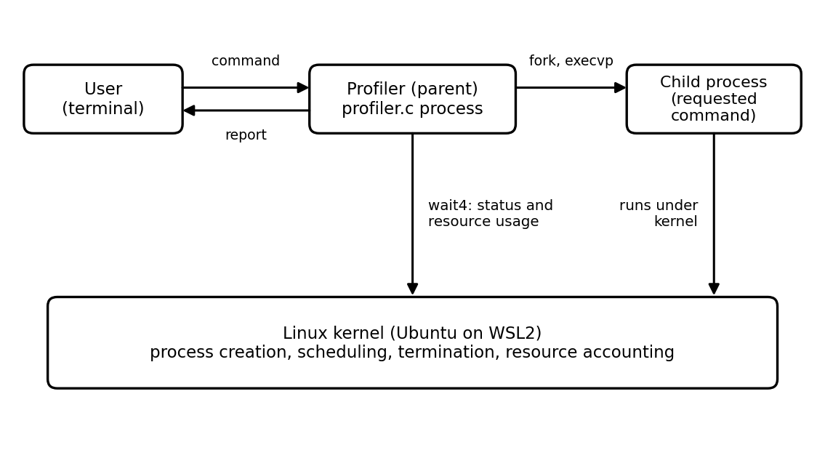
Figure 1: High-level architecture of the profiler
The profiler is a single C source file with one main() function containing an input loop. There are no separate modules or configuration files. The parent process performs all input handling, timing and reporting. The child process exists only to run the requested command.

8. Program Execution Workflow
The workflow below follows the control flow of profiler.c. Each iteration of the main loop handles one command.
- Print the banner and prompt, and flush standard output.
- Read one line with fgets(). If end-of-input is reached, leave the loop.
- If the line did not fit in the 256-byte buffer, discard the rest of the line, print "Error: Command is too long." and return to the prompt.
- Remove the trailing newline. If the line is empty, print "Error: Empty command." and return to the prompt.
- If the line is exactly exit, print "Exiting profiler. Goodbye!" and leave the loop.
- Split the line into a command name and arguments using strtok() with space and tab separators.
- Record the start time with clock_gettime(CLOCK_MONOTONIC).
- Call fork(). In the child, call execvp(); if it fails, print an error with perror() and exit with status 127.
- In the parent, call wait4() to wait for the child and obtain its status and resource usage.
- Record the end time and compute the elapsed time.
- Print the execution report and return to step 1.
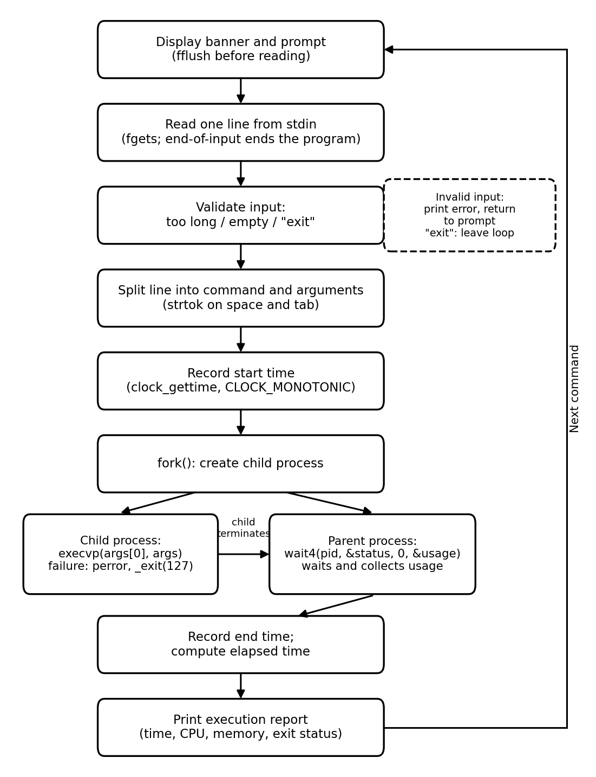
Figure 2: Program execution workflow of the profiler
The diagram matches the source code: the input is validated before any process is created, timing starts immediately before fork() and ends after wait4() returns, and control always returns to the prompt unless the user types exit or input ends.

9. Methodology and Implementation
This section describes how each part of profiler.c is implemented. The complete listing is given in Appendix A.

9.1 Input Handling
The command is read into a 256-byte buffer (MAX_COMMAND) using fgets(). If no newline appears in the buffer, the line was longer than the buffer, so the remaining characters are read and discarded and an error is shown. The newline is then removed with strcspn(). Empty input and the word exit are handled before any process is created.
if (fgets(command, sizeof(command), stdin) == NULL)
break;

if (strchr(command, '\n') == NULL && !feof(stdin)) {
int ch;
while ((ch = getchar()) != '\n' && ch != EOF)
;
printf("Error: Command is too long.\n");
continue;
}
command[strcspn(command, "\n")] = '\0';
Listing 1: Reading and validating a line of input

9.2 Parsing the Command
The line is split at spaces and tabs by strtok(). Pointers to the tokens are stored in the args array, which holds at most MAX_ARGS (64) entries. The loop stops at 63 tokens so that one slot always remains for the terminating NULL pointer that execvp() requires. This is simple splitting only; the program does not interpret quotes, pipes or redirection.
char *args[MAX_ARGS];
int count = 0;
char *token = strtok(command, " \t");

while (token != NULL && count < MAX_ARGS - 1) {
args[count++] = token;
token = strtok(NULL, " \t");
}
args[count] = NULL;
Listing 2: Splitting the command into arguments

9.3 Process Creation, Timing and Waiting
The start time is recorded just before fork(). In the child (pid == 0) the program calls execvp(args[0], args). In the parent, wait4() blocks until the child terminates and fills in the status and usage variables. The end time is read after wait4() returns.
clock_gettime(CLOCK_MONOTONIC, &start);
pid_t pid = fork();

if (pid == 0) {
execvp(args[0], args);
perror("Command execution failed");
_exit(127);
}

wait4(pid, &status, 0, &usage);
clock_gettime(CLOCK_MONOTONIC, &end);
Listing 3: Core of the measurement logic (error checks omitted for brevity; the full code checks each call)

9.4 Computing and Reporting Results
Elapsed time is computed as the difference of the two timestamps, combining seconds and nanoseconds into a double. User CPU time (ru_utime) and system CPU time (ru_stime) are printed in seconds with microsecond resolution. Maximum memory (ru_maxrss) is printed in kilobytes. If the child ended normally (WIFEXITED), its exit code is printed with WEXITSTATUS; if it was killed by a signal (WIFSIGNALED), the signal number is printed with WTERMSIG.

9.5 Error Handling
Each system call that can fail (clock_gettime(), fork(), wait4()) is checked, and perror() prints a message before the loop continues with the next command. If execvp() fails, for example because the command does not exist, the child prints "Command execution failed" followed by the system error text and exits with status 127. The parent still waits for this child and prints a normal execution report, so the profiler keeps running.
The program flushes standard output before reading input (fflush(stdout)), so no unwritten text is duplicated into the child by fork().

10. Important Linux System Calls and APIs

10.1 fork()
fork() creates a new process by duplicating the calling process. It returns twice: it returns 0 in the child and the child's process ID in the parent, and -1 on failure. The profiler uses the return value to decide whether the current code is running in the child or the parent.

10.2 execvp()
execvp(file, argv) replaces the current process image with a new program. The p in the name means that, if file contains no slash, the directories listed in the PATH environment variable are searched. The v means the arguments are passed as an array that must end with NULL. On success execvp() does not return. It returns only on failure, which is why code placed after it (the perror() and _exit(127)) runs only when the command could not be executed.

10.3 wait4()
wait4(pid, &status, options, &rusage) waits for the given child to change state, like waitpid(), and additionally fills a struct rusage with the resource usage of the terminated child. It is a Linux/BSD extension rather than a POSIX function; the source file therefore defines _GNU_SOURCE before including headers. The status value is decoded with the macros WIFEXITED, WEXITSTATUS, WIFSIGNALED and WTERMSIG.

10.4 struct rusage
Field | Meaning in this project
ru_utime | CPU time spent executing user-space code (printed as User CPU time).
ru_stime | CPU time spent in the kernel on behalf of the process (printed as System CPU time).
ru_maxrss | Maximum resident set size. On Linux it is reported in kilobytes (printed as Max memory).
Table 3: Fields of struct rusage used by the profiler

10.5 clock_gettime()
clock_gettime(clockid, &ts) reads a clock into a struct timespec (seconds and nanoseconds). CLOCK_MONOTONIC is a clock that moves steadily forward and is not affected by changes to the system date and time, which makes it suitable for measuring intervals. The measured interval is wall-clock (real) time, so it includes time spent waiting or sleeping, not only time spent computing.

10.6 Supporting functions
- fgets() reads a line of input safely into a fixed-size buffer.
- strtok() splits a string into tokens; it modifies the original buffer by inserting terminating characters.
- strcspn() finds the position of the newline so that it can be replaced by '\0'.
- perror() prints a message followed by a description of the current errno value.
- _exit() terminates the child immediately without running normal exit handlers; it is the appropriate way for a child to leave after a failed exec.

11. Compilation and Execution Procedure
Open a Linux terminal, change to the project directory, compile and run:
cd ~/linux-command-profiler
gcc -Wall -Wextra profiler.c -o profiler
./profiler
Listing 4: Build and run commands
The -Wall -Wextra options enable additional compiler warnings, and -o profiler names the output executable. Figure 3 shows the source file being opened with nano profiler.c, the compilation command, and the profiler starting and displaying its command prompt. No compiler messages are visible between the compilation command and the program start in this screenshot.
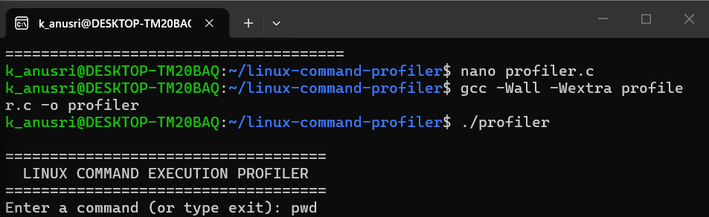

Figure 3: Compilation and program startup of the Linux Command Execution Time Profiler
After the program starts, the user types a simple, space-separated Linux command at the prompt, for example pwd, ls -l or sleep 2. The profiler runs the command, prints its output and then the execution report. This repeats until the user types exit.
Important: the current implementation does not provide full shell parsing. Shell pipelines (|), redirection (>, <), shell operators (&&, ;) and complex quoted arguments are not supported.

12. Testing Methodology and Test Cases
Testing was manual and black-box: each command was typed at the profiler prompt and the printed output and execution report were compared with the expected behaviour. The six tests were chosen to cover the normal path, the timing behaviour, the error path and the input-handling paths.
Test ID | Input | Expected behaviour | Actual observed result | Status
T1 | pwd | Prints the working directory, then the execution report with exit status 0. | Recorded as passed in the project README. No screenshot or exact values were supplied for this report. | Reported passed (not screenshot-verified)
T2 | ls -l | Prints the directory listing, then the report with exit status 0. | Listing shown; elapsed 0.005022 s; user CPU 0.000000 s; system CPU 0.004770 s; max memory 8644 KB; exit status 0 (Figure 4). | Verified (screenshot)
T3 | sleep 2 | Elapsed time of about 2 s; CPU time much lower than elapsed time. | Elapsed 2.003424 s; user CPU 0.000000 s; system CPU 0.003018 s; max memory 8016 KB; exit status 0 (Figure 5). | Verified (screenshot)
T4 | abcxyz | Execution error message; exit status 127; profiler keeps running. | Message "Command execution failed: No such file or directory"; elapsed 0.223443 s; user CPU 0.000000 s; system CPU 0.006032 s; max memory 1064 KB; exit status 127 (Figure 6). | Verified (screenshot)
T5 | Empty input (Enter only) | Prints "Error: Empty command." and shows the prompt again. | Recorded as passed in the project README. No screenshot supplied; the message text is taken from the source code. | Reported passed (not screenshot-verified)
T6 | exit | Prints "Exiting profiler. Goodbye!" and terminates the program. | Recorded as passed in the project README. No screenshot supplied; the message text is taken from the source code. | Reported passed (not screenshot-verified)
Table 4: Test cases. "Verified" means the values appear in the supplied terminal screenshots; "Reported passed" means the result is recorded in the README only.

12.1 Purpose of Each Test
- pwd validates the simplest successful command with no arguments.
- ls -l validates a command with an argument and visible output, confirming that arguments are passed on correctly.
- sleep 2 validates the timing measurement: the command does almost no computation but takes a known amount of real time.
- abcxyz validates the error path: a command that does not exist must be reported and must not stop the profiler.
- Empty input validates input checking before any process is created.
- exit validates the normal way of ending a session.

13. Results and Discussion

13.1 Normal Command Execution: ls -l
Figure 4 shows ls -l executed through the profiler. The directory listing contains the files profiler and profiler.c, followed by the execution report. The report shows an elapsed time of 0.005022 seconds, user CPU time of 0.000000 seconds, system CPU time of 0.004770 seconds, maximum memory of 8644 KB and exit status 0. Exit status 0 indicates that the command completed successfully.
The "Command" line of the report shows only ls, not ls -l. This is because the program prints args[0], the command name, and not the full argument list.
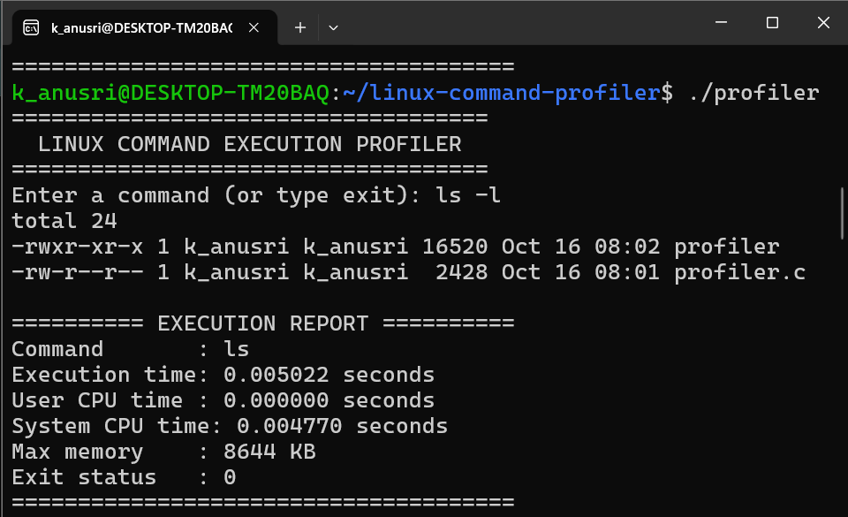
Figure 4: Normal command execution using ls -l

13.2 Timing Validation: sleep 2
Figure 5 shows sleep 2. The measured elapsed time is 2.003424 seconds, which is approximately two seconds as expected. User CPU time is 0.000000 seconds and system CPU time is 0.003018 seconds, far below the elapsed time. This is consistent with the nature of sleep: the process spends almost all of its life blocked waiting for the timer rather than executing instructions, so wall-clock time and CPU time differ greatly. The maximum memory is 8016 KB and the exit status is 0.
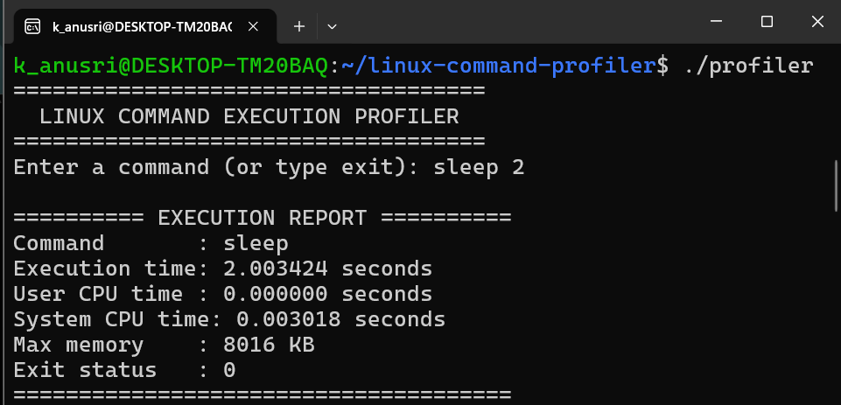
Figure 5: Timing validation using sleep 2

13.3 Error Handling: abcxyz
Figure 6 shows the invalid command abcxyz. Because no such program exists, execvp() fails in the child. The child prints "Command execution failed: No such file or directory" with perror() and exits with status 127, using _exit(127) in the source. The parent then completes wait4() normally and prints the execution report, which shows an elapsed time of 0.223443 seconds, user CPU time of 0.000000 seconds, system CPU time of 0.006032 seconds, maximum memory of 1064 KB and exit status 127.
The error line appears before the report because the child writes it before it exits, and the parent prints the report only after wait4() returns. The screenshot is cropped after the report, so the next prompt is not visible; the continuation of the session is confirmed by the loop structure of the source code, in which control returns to the prompt after every report. The value 127 matches the common shell convention for "command not found".
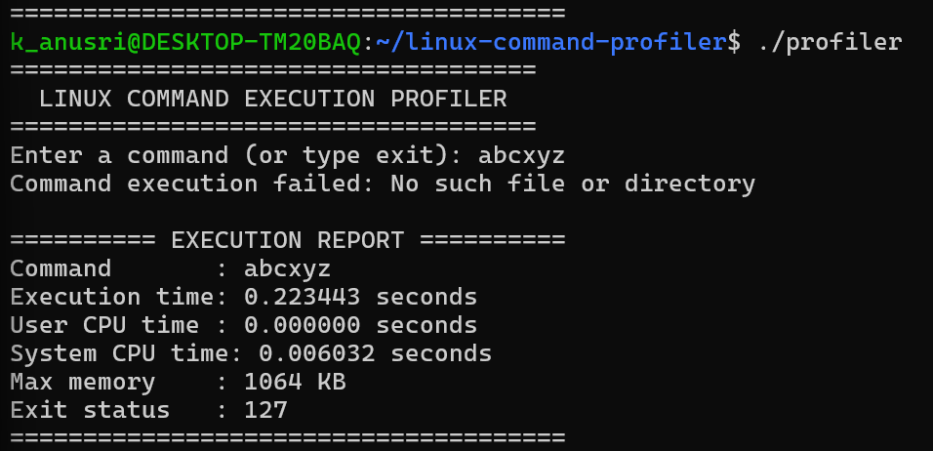
Figure 6: Invalid command handling using abcxyz

13.4 Summary of Observed Values
Test | Elapsed (s) | User CPU (s) | System CPU (s) | Max memory (KB) | Exit status
ls -l | 0.005022 | 0.000000 | 0.004770 | 8644 | 0
sleep 2 | 2.003424 | 0.000000 | 0.003018 | 8016 | 0
abcxyz | 0.223443 | 0.000000 | 0.006032 | 1064 | 127
Table 5: Values observed in the terminal screenshots (single runs)

13.5 Discussion
- The profiler correctly distinguishes elapsed time from CPU time, which is the main lesson of the sleep 2 test.
- Each value is from a single run. Timing and resource usage may vary between runs because of scheduling, caching, the state of the system and the WSL2 environment. The values in Table 5 should therefore be read as examples of observed output, not as fixed or benchmark figures.
- The elapsed time of the failed command (0.223443 s) is larger than that of ls -l, although the command did not run. A single run is not enough to explain the difference, and no cause was investigated for this report.
- The memory figures are those reported by Linux for the child process in each run. They are not comparisons of the commands' efficiency.
- Elapsed time includes the cost of fork() and execvp() as well as the command itself, because the start time is taken before fork().

14. Actual Terminal Screenshots
All screenshots in this report are authentic captures of the project running in an Ubuntu (WSL2) terminal. They have not been redrawn or altered. Table 6 lists them and the sections where they appear.
Figure | Content | Command | Appears in
Figure 3 | Compilation and program startup | nano, gcc, ./profiler | Section 11
Figure 4 | Normal command execution | ls -l | Section 13.1
Figure 5 | Timing validation | sleep 2 | Section 13.2
Figure 6 | Invalid command handling | abcxyz | Section 13.3
Table 6: Index of terminal screenshots
Screenshots for pwd, empty input and exit were not supplied. They can be added as Figures 7 to 9 if the team captures them (see the placeholders below).
[Placeholder: Figure 7] Screenshot of pwd executed in the profiler, showing the working directory and the execution report. 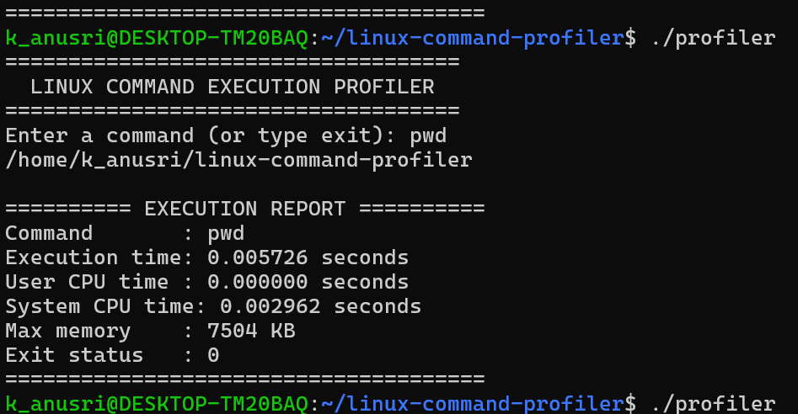

[Placeholder: Figure 8] Screenshot of an empty input (pressing Enter) showing "Error: Empty command." 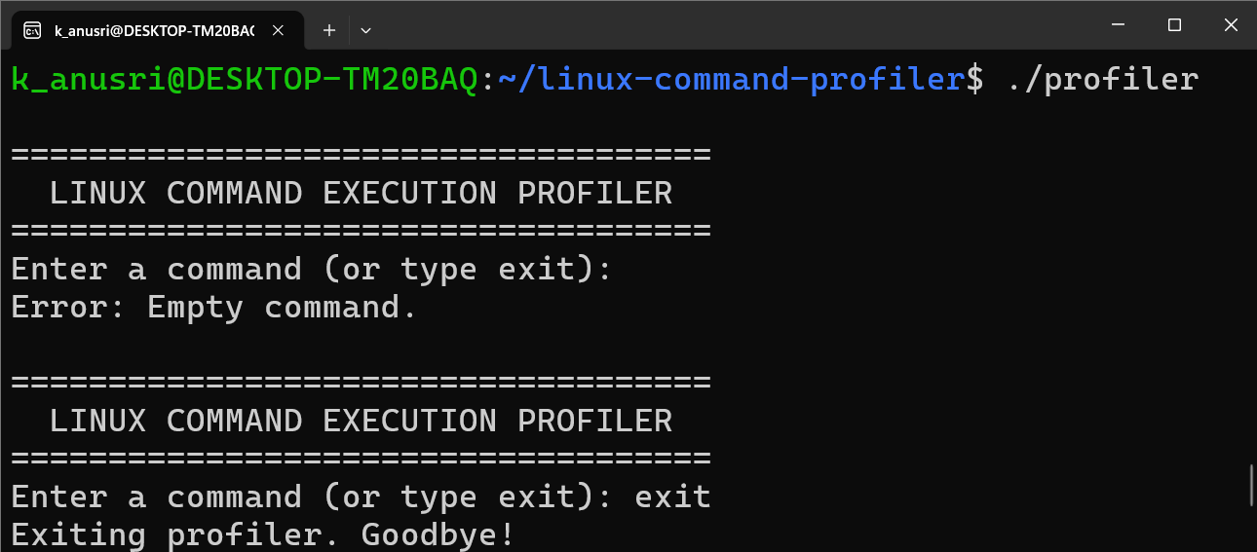

[Placeholder: Figure 9] Screenshot of exit showing "Exiting profiler. Goodbye!" 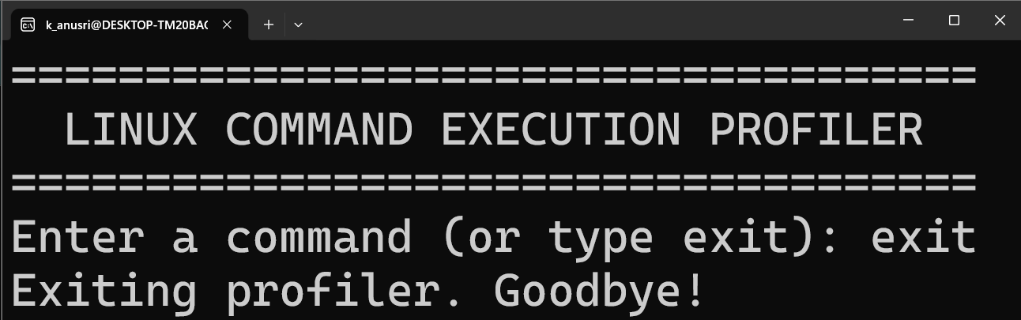

15. Limitations
- No shell parsing. Commands are split only at spaces and tabs. Pipes, redirection, shell operators and arguments containing embedded spaces or quotation marks are not supported.
- Built-in shell commands are not available. Commands are run with execvp(), so only programs found on PATH can be executed; shell built-ins such as cd are not programs.
- Fixed limits. A line longer than 255 characters is rejected, and at most 63 tokens are kept; any further tokens are silently ignored.
- Strict exit detection. exit is recognised only when it is the whole line; leading or trailing spaces make it an ordinary command, which then fails with status 127.
- Report shows only the command name. The "Command" line prints the first token, not the full command line.
- Environment-dependent measurements. Results depend on the Linux environment, system load and the command being run, and single runs vary.
- Limited testing. Only the manual tests in Table 4 have been performed. Signal termination, very long input and commands with many arguments have not been tested.

16. Future Enhancements
- Support command history and saved reports.
- Export execution reports to a CSV file.
- Compare resource usage across multiple commands or repeated runs.
- Add more advanced command-line parsing, for example quoted arguments.
- Print the full command line in the report.
- Run a command several times and report the average and spread of the measurements.

17. Team Contributions
The project was carried out by a team of four students under the guidance of V MUNIRAJU. All four team members are acknowledged. The contributions that have been confirmed so far are shown below; fields marked as pending must be completed by the team, as no further information was available when this report was prepared.
S. No. | Roll Number | Student Name | Contribution
1 | 2520030432 | K ANUSRI | Primary implementation and development of the project.
2 | 2520030440 | K SAI ANSHU | Linux research and requirements review
3 | 2520030193 | K DHEERAJ | Testing and output verification.
4 | 2520030028 | B MOHITH | Documentation and PPT preparation.
Table 7: Team contributions

18. Conclusion
The Linux Command Execution Time Profiler meets its stated objectives. It runs simple Linux commands through the fork–exec–wait mechanism, reports elapsed time, user CPU time, system CPU time, maximum resident memory and exit status, handles invalid and empty input, and accepts multiple commands in one session. The observed results for ls -l, sleep 2 and abcxyz agree with the behaviour expected from the source code, including an elapsed time of about two seconds for sleep 2 and exit status 127 for the invalid command.
The project also illustrates several core Operating Systems ideas: process creation, program execution, process waiting, and the difference between wall-clock time and CPU time. Its main limitation is the lack of shell parsing, and the testing so far is limited to the manual cases documented here. The enhancements listed in Section 16 offer natural directions for further work.

19. References
[1] Linux man-pages project. fork(2). https://man7.org/linux/man-pages/man2/fork.2.html
[2] Linux man-pages project. execvp(3), documented in exec(3). https://man7.org/linux/man-pages/man3/exec.3.html
[3] Linux man-pages project. wait4(2). https://man7.org/linux/man-pages/man2/wait4.2.html
[4] Linux man-pages project. wait(2) (status macros WIFEXITED, WEXITSTATUS, WIFSIGNALED, WTERMSIG). https://man7.org/linux/man-pages/man2/wait.2.html
[5] Linux man-pages project. getrusage(2) (struct rusage). https://man7.org/linux/man-pages/man2/getrusage.2.html
[6] Linux man-pages project. clock_gettime(2). https://man7.org/linux/man-pages/man2/clock_gettime.2.html
[7] Linux man-pages project. _exit(2). https://man7.org/linux/man-pages/man2/_exit.2.html
[8] Linux man-pages project. perror(3). https://man7.org/linux/man-pages/man3/perror.3.html
[9] Linux man-pages project. strtok(3). https://man7.org/linux/man-pages/man3/strtok.3.html
[10] Linux man-pages project. fgets(3). https://man7.org/linux/man-pages/man3/fgets.3.html
[11] Linux man-pages project. feature_test_macros(7) (for _GNU_SOURCE). https://man7.org/linux/man-pages/man7/feature_test_macros.7.html
[12] GNU Project. Using the GNU Compiler Collection (GCC), Warning Options (-Wall, -Wextra). https://gcc.gnu.org/onlinedocs/gcc/Warning-Options.html
[13] cppreference.com. C reference. https://en.cppreference.com/w/c
[14] Microsoft. Windows Subsystem for Linux documentation. https://learn.microsoft.com/en-us/windows/wsl/
[15] Git. Git documentation. https://git-scm.com/doc
[16] GitHub. GitHub Docs. https://docs.github.com
[17] Project README and source file, README.md and profiler.c, repository kanusri-tmj/linux-command-profiler.

20. GitHub Repository Information
Item | Details
Repository | https://github.com/kanusri-tmj/linux-command-profiler
Owner account | kanusri-tmj
Visibility | Public
Branch | main
Files in repository | README.md, profiler.c
Description | A C-based Linux tool to measure command execution time and resource usage.
Clone command | git clone https://github.com/kanusri-tmj/linux-command-profiler.git
Table 8: GitHub repository information
The repository page was checked while preparing this report (16 October 2026); it listed the two files above on the main branch, with one commit. The repository contents may change after this date.

Appendix A: Complete Source Code (profiler.c)

#define _GNU_SOURCE
#include <stdio.h>
#include <stdlib.h>
#include <string.h>
#include <time.h>
#include <unistd.h>
#include <sys/wait.h>
#include <sys/resource.h>

#define MAX_COMMAND 256
#define MAX_ARGS 64

int main(void)
{
char command[MAX_COMMAND];

while (1) {
printf("\n====================================\n");
printf(" LINUX COMMAND EXECUTION PROFILER\n");
printf("====================================\n");
printf("Enter a command (or type exit): ");
fflush(stdout);

if (fgets(command, sizeof(command), stdin) == NULL)
break;

if (strchr(command, '\n') == NULL && !feof(stdin)) {
int ch;
while ((ch = getchar()) != '\n' && ch != EOF)
;
printf("Error: Command is too long.\n");
continue;
}

command[strcspn(command, "\n")] = '\0';

if (command[0] == '\0') {
printf("Error: Empty command.\n");
continue;
}

if (strcmp(command, "exit") == 0) {
printf("Exiting profiler. Goodbye!\n");
break;
}

char *args[MAX_ARGS];
int count = 0;
char *token = strtok(command, " \t");

while (token != NULL && count < MAX_ARGS - 1) {
args[count++] = token;
token = strtok(NULL, " \t");
}
args[count] = NULL;

if (count == 0) {
printf("Error: Empty command.\n");
continue;
}

struct timespec start, end;
struct rusage usage;
int status;

if (clock_gettime(CLOCK_MONOTONIC, &start) == -1) {
perror("clock_gettime");
continue;
}

pid_t pid = fork();

if (pid < 0) {
perror("fork");
continue;
}

if (pid == 0) {
execvp(args[0], args);
perror("Command execution failed");
_exit(127);
}

if (wait4(pid, &status, 0, &usage) == -1) {
perror("wait4");
continue;
}

if (clock_gettime(CLOCK_MONOTONIC, &end) == -1) {
perror("clock_gettime");
continue;
}

double elapsed = (end.tv_sec - start.tv_sec)
+ (end.tv_nsec - start.tv_nsec) / 1e9;

printf("\n========== EXECUTION REPORT ==========\n");
printf("Command : %s\n", args[0]);
printf("Execution time : %.6f seconds\n", elapsed);
printf("User CPU time : %ld.%06ld seconds\n",
(long)usage.ru_utime.tv_sec,
(long)usage.ru_utime.tv_usec);
printf("System CPU time: %ld.%06ld seconds\n",
(long)usage.ru_stime.tv_sec,
(long)usage.ru_stime.tv_usec);
printf("Max memory : %ld KB\n", usage.ru_maxrss);

if (WIFEXITED(status))
printf("Exit status : %d\n", WEXITSTATUS(status));
else if (WIFSIGNALED(status))
printf("Terminated by signal: %d\n", WTERMSIG(status));

printf("======================================\n");
}

return 0;
}

